JavaScript Array Methods and For Loop

1. push() – Add element at the end
Description:
push() adds a new element to the end of an array.
Syntax:
array.push(element);
Example:
let fruits = ["Apple", "Banana"];
fruits.push("Mango");
console.log(fruits);
Output:
["Apple", "Banana", "Mango"]

2. pop() – Remove last element
Description:
pop() removes the last element from the array.
Syntax:
array.pop();
Example:
let fruits = ["Apple", "Banana", "Mango"];
fruits.pop();
console.log(fruits);
Output:
["Apple", "Banana"]

3. shift() – Remove first element
Description:
shift() removes the first element from the array.
Syntax:
array.shift();
Example:
let fruits = ["Apple", "Banana", "Mango"];
fruits.shift();
console.log(fruits);
Output:
["Banana", "Mango"]

4. unshift() – Add element at the beginning
Description:
unshift() adds a new element to the beginning of the array.
Syntax:
array.unshift(element);
Example:
let fruits = ["Banana", "Mango"];
fruits.unshift("Apple");
console.log(fruits);
Output:
["Apple", "Banana", "Mango"]

5. Print Array Elements Using For Loop
Description:
A for loop is used to repeat a block of code. It helps to print all elements of an array one by one using index.
Syntax:
for(initialization; condition; increment) {
// code
}
Example:
let fruits = ["Apple", "Banana", "Mango"];
for(let i = 0; i < fruits.length; i++) {
console.log(fruits[i]);
}
Output:
Apple
Banana
Mango

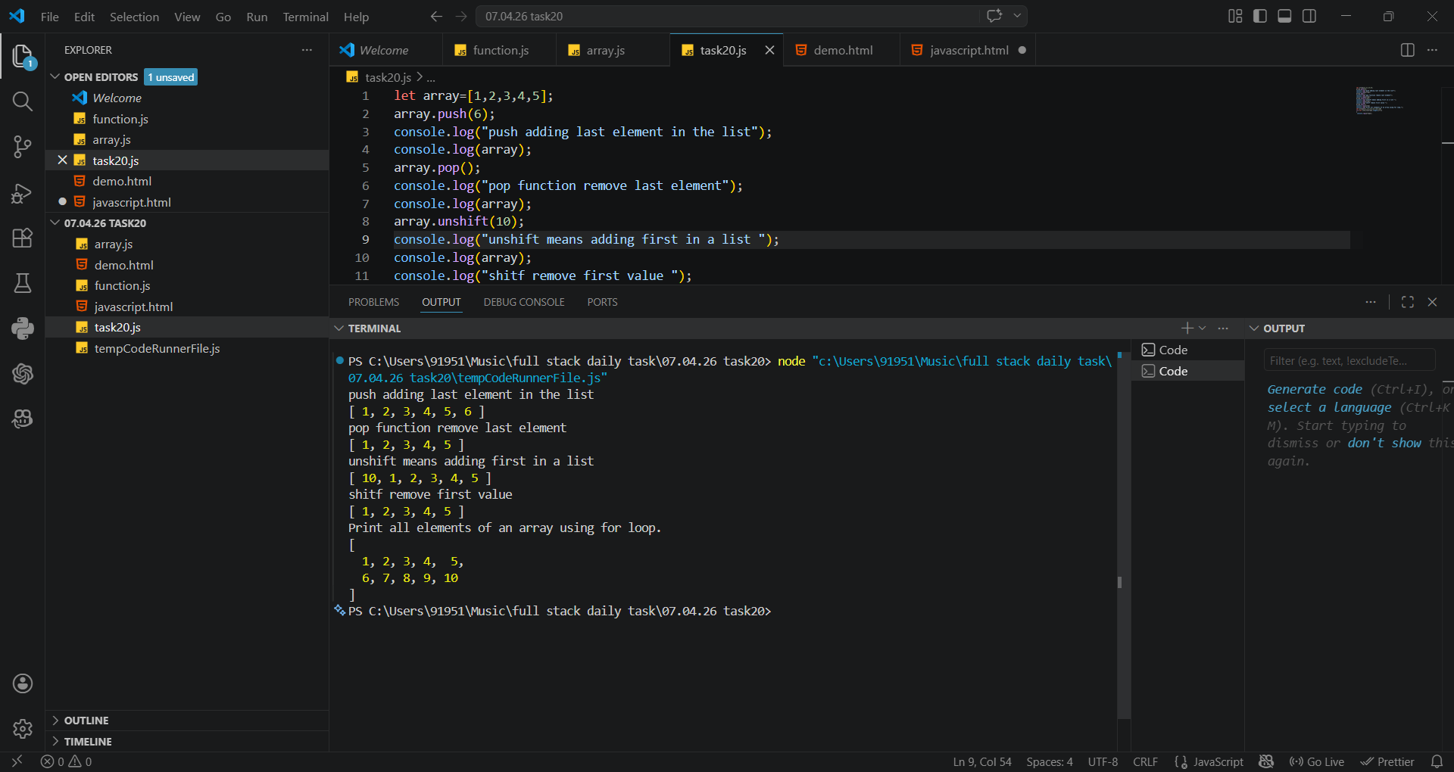
OUTPUT:

